

CAPTION: Bongki Shin is a materials science and nanoengineering graduate student at Rice University and a first author on a paper published in the journal Matter.

(Photo by Gustavo Raskoksy/Rice University)  
  
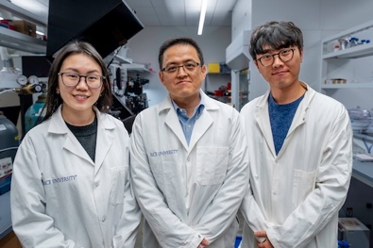

CAPTION: Yimo Han (from left), Jun Lou and Bongki Shin

(Photo by Gustavo Raskoksy/Rice University)

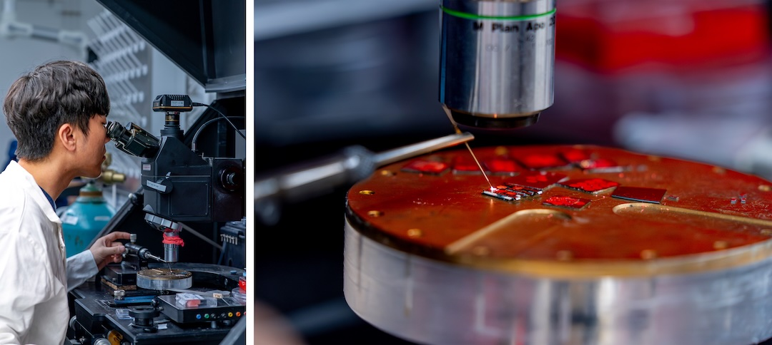

CAPTION: Bongki Shin (left) in the lab handling a micro-manipulator, a device equipped with a sharp tungsten tip (right) used for cutting 2D materials. (Photos by Gustavo Raskoksy/Rice University)